

**A**

**PROJECT REPORT**

**FOR**

**SUBJECT: LAB II- PROJECT PHASE II**

**ON**

**“Zona Del Silencio”**

Submitted in partial fulfilment of the requirement for the award of

**Bachelor of Engineering**

**In**

**Computer Science and Engineering**

**Punyashlok Ahilyadevi Holkar Solapur University**

By

|  |  |
| --- | --- |
| Shravani Virswami Dasari | 30 |
| Utkarsha Sanjay Kandale | 31 |
| Sanket Anilkumar Munot | 32 |
| Rupam Ashok Pusdekar | 33 |

Under the Guidance of

**Prof. Mrs. S. S. Ambarkar**



**DEPARTMENT OF COMPUTER SCIENCE AND ENGINEERING**

**WALCHAND INSTITUTE OF TECHNOLOGY**

**SOLAPUR - 413006**

**(2019-2020)**



**Certificate**

This is to certify that the project entitled

**“Zona Del Silencio”**

Is submitted by

|  |  |
| --- | --- |
| Shravani Virswami Dasari | 30 |
| Utkarsha Sanjay Kandale | 31 |
| Sanket Anilkumar Munot | 32 |
| Rupam Ashok Pusdekar | 33 |

**(Prof. Mrs. S. S. Ambarkar) *Project Guide***

**(Dr. Mrs. A. M. Pujar)**

***Head CSE Dept***

**Dr. S. A. Halkude**

***Principal***

**DEPARTMENT OF COMPUTER SCIENCE AND ENGINEERING**

**WALCHAND INSTITUTE OF TECHNOLOGY**

**SOLAPUR - 413006**

**(2019-2020)**

**Project Approval Sheet**

The Project Entitled

**“Zona Del Silencio”**

Submitted by

|  |  |
| --- | --- |
| Shravani Virswami Dasari | 30 |
| Utkarsha Sanjay Kandale | 31 |
| Sanket Anilkumar Munot | 32 |
| Rupam Ashok Pusdekar | 33 |

“Is hereby approved in partial fulfilment for the degree of

Bachelor of Computer Science and Engineering”

**(Dr. Mrs. A. M. Pujar)**

***Head CSE Dept***

**(Prof. Mrs. S. S. Ambarkar) *Project Guide***

**Dr. S. A. Halkude**

***Principal***

**DEPARTMENT OF COMPUTER SCIENCE AND ENGINEERING**

**WALCHAND INSTITUTE OF TECHNOLOGY**

**SOLAPUR - 413006**

**(2019-2020)**

**Acknowledgment**

At the outset, we would like to take this opportunity to express our deep gratitude to our guide **Prof. Mrs. S. S. Ambarkar** of CSE Department for his guidance and moral support throughout this successful completion of our project.

We heartily thank **Dr. Mrs. A. M. Pujar,** Head of CSE Dept. for her moral support and promoting us through completion of our project.

We would also like to thank our Principal **Dr. S. A. Halkude** and all staff members for their whole hearted co-operation in completing this project.

**UNDERTAKING**

We solemnly declare that project work presented in the report titled **Zona Del Silencio** is solely my project work with no significant contribution from any other person except project guide. Small contribution/help wherever taken has been duly acknowledged and that complete report has been written by the members of the project group.

We understand the zero tolerance policy of the WIT, Solapur and University towards plagiarism. Therefore we as Authors of the above titled report declare that no portion of the report has been plagiarized and any material used as reference is properly referred / cited.

We undertake that if found guilty of any formal plagiarism in the above titled report even after award of the degree, WIT, Solapur and Solapur University reserves the rights to withdraw/revoke the degree granted and that WIT, Solapur and the University has the right to publish our name on the website on which names of students are placed who submitted plagiarized report.

|  |  |  |  |
| --- | --- | --- | --- |
| Name of Student | Exam Number | University PRN Number | Signature |
| Shravani Virswami Dasari |  | 2016032500227094 |  |
| Utkarsha Sanjay Kandale |  | 2016032500227925 |  |
| Sanket Anilkumar Munot |  | 2016032500226164 |  |
| Rupam Ashok Pusdekar |  | 2016032500228302 |  |

Date: / /

**Abstract**

"Silent Zones" we often see this sign passing by the roads. Ever wondered what they are? The areas such as Hospitals, libraries, schools, courts come normally under silent zones. It is done so that the people in hospitals, readers in the library, Students and courtrooms experience no disturbance in the atmosphere and they can concentrate on the work being done. According to the standards, noise level in the silent zone should not exceed 50 dB during the daylight and 40 dB after dusk. But, as seen there is large variation on how much the sound levels vary from 56 dB to even as high as 77 dB for the day time and from 51 dB to 75 dB after the dawn. The solution to this increasing problem, “Zona Del Silencio” is a device which will be connected to the vehicle, upon entering the no-honking-zones the device will suppress honking of vehicles by drivers. Taking in consideration of emergency scenarios, an emergency switch is provided for the user to use, thus misuse of this switch is detected via sensors and the user is penalised.

An online user interface is created for the vehicle owner to interact for bills as well as a host service application for authority to monitor the fines is provided. With implementation of Zona Del Silencio effective reduction of noise in surrounding silence zones can be observed

**Index**

|  |  |  |  |
| --- | --- | --- | --- |
| **Sr. No.** | **Title** | | **Page No.** |
| **1** | **Introduction** | | 01 |
|  | 1.1 | Introduction | 02 |
|  | 1.2 | Problem Statement and Objective | 03 |
| **2** | **Background** | | 05 |
| **3** | **Proposed Solution** | | 10 |
|  | 3.1 | Solution | 11 |
|  | 3.2 | Advantages of proposed system | 12 |
| **4** | **Working Environment** | | 13 |
|  | 4.1 | Hardware Requirements | 14 |
|  | 4.2 | Software Requirements | 16 |
| **5** | **Methodology** | | 17 |
|  | 5.1 | System Architecture | 18 |
|  | 5.2 | Work Flow | 20 |
| **6** | **Implementation** | | 22 |
|  | 6.1 | Code Snippet | 23 |
|  | 6.2 | Screenshots & Results | 28 |
| **7** | **Flow diagrams** | | 32 |
|  | 7.1 | Data Flow Diagrams | 33 |
|  | 7.2 | Sequential UML Diagram | 36 |
| **8** | **Project Cost** | | 38 |
| **9** | **Future Work** | | 40 |
| **10** | **Conclusion** | | 42 |
| **11** | **References** | | 44 |

**Chapter 1**

**INTRODUCTION**

**1.1 Introduction -**

IoT or Internet of Things, there are numerous physical devices around the globe that are connected to the network. These electronic devices are also called smart devices as all of them collect and share data around their surroundings. These devices are also capable of taking different actions with respect to change in their ecosystem.

In the world of smart devices it is possible due to cheap computer chips, strong and robust wireless networks which helps devices to share data with each other. The intelligence which make these devices smart is because of various sensors and actuators which sense and takes appropriate actions to interact with respective ecosystem, without these sensors and actuators this devices would still be dumb which would require human involvement to read data and take actions. The Internet of Things is the link which connects the differences of physical and digital worlds.

The field of Internet of Things opens a wide variety of opportunities to industrial automation, medical institutions, food industry, traffic maintenance, disaster management etcetera. These devices can keep watch on working parts of an industry to predict depreciation of huge machines. IoT when used in the agriculture field may enhance yield and subsequently decrease the losses faced by a farmer devices such as temperature and wind sensors can help predict rain, soil and moisture sensors to help to check the moisture and contents of soil. Similarly IoT can automate inventory management by keeping the produced goods in the store rooms and keeping up to date records using RFID technology.

IoT consists of embedded systems such as processors, sensors, actuators and communication hardware this ecosystem collects and sends any act of their ecosystem to other devices or a central storage. IoT devices perform all the work almost by themselves, human interaction is required for a handful of purposes like set them, send updates regularly. IoT can also make use of artificial intelligence (AI) and machine learning to use collected data for preparing models and making quality predictions.

Advantages of IoT:

* Resource utilisation - The proper knowledge of how each device and sensor works definitely increases the resource utilisation.
* Enhanced data collection - Data collection rate with IoT devices is exponentially high and is capable of generating big data
* Minimise human interaction - With setup of IoT devices once very less human interaction is needed for working.

Zona Del Silencio is an IoT device which can help in reducing growing noise pollution by attaching it to every private vehicle except emergency vehicles - ambulance, police van, fire truck. The device uses Wi-Fi to establish network and internet access, it works in parallel with a web app which consists of modular API’s for a more modular working environment. User interface in the form of a website is also prepared for users to interact.

**1.2 Problem Statement**

|  |
| --- |
| “Silence Zones were identified by the MCGM after a Bombay High Court Order directed them to identify and place Silence Zone boards within a week in 2009. In its Order and Judgment of August 2016, the Bombay High Court ruled that Silence Zones do not require any specific Notification by the Government, so long as an area fulfils required definitions. After a failed challenge to the Supreme Court of India, the State is bound to implement Silence Zones in Maharashtra in accordance with Noise Rules and Bombay High Court Orders” - Awaaz Foundation.  The Silent Zones are facing a severe issue of noise pollution which is causing a humongous disturbance to the people. According to the World Health Organization (WHO), the sound level of 60 dB can cause a person temporary deafness, while sound levels of 100 dB can lead to deafness permanently. In heavily urbanized cities it is becoming a serious issue. People tend to abruptly ignore the rules made for silent zones and use horns without reason. Many a time it is observed people make honking while on a signal which is wrong as it causes disturbance in surrounding areas.  “Zona Del Silencio” is a device connected to the vehicle which will act as a noise barrier upon such areas, upon entering in silent zones this device will suppress honking of vehicles by disabling the horn mechanism of the vehicle with which even on pressing the button horn won’t be made. In case of an emergency, the driver will be provided with a restricted emergency switch mechanism.  With employment of Zona Del Silencio noise pollution levels will be decreased in the silence zones thus maintaining the integrity of the silence zone. A system to penalize the mischievous drivers would be obtained under the control of traffic authorities.  **OOBJECTIVES**  Implement an IoT based prototype which will interact with the Wi-Fi routers installed in the silent zones and suppress the honking mechanism of the vehicle to maintain the integrity of these zones.  Traditional horn mechanism is disabled and an emergency mechanism with a second switch is to be made active for emergency situations. Additionally, maintaining the records i.e the count for which the emergency switch has been used mischievously, this record is maintained at the remote database.  The right owner of the vehicle would be confirmed by using a mac address which is unique and would be integrated with the vehicle number of the user while attaching the device. This mac ID is used as a key in API to interact with the count of the specific driver.  To ensure the rightful use of the emergency switch, the device will be integrated with a sensor such as IR sensor to check the existence of a vehicle which is in front of the honking vehicle.  An open API to get records of all the instances of misuse of emergency switch to create a host service for the admin.    **Chapter 2**  **Background** |

**1.**    **Library sound level meter [1]**

The Library Noise Detector is a portable device that is used in detecting noise in the library with a Short Information Provider. This device is used to control excessive noise inside the library. Fig 2.1.1

This device placed in the library detects sound from the library and displays in the form of analog reading or a digital display. These readings can be monitored for a specific threshold and an alarm is raised when the sound increases beyond this threshold. Thus acting as an alarm system.

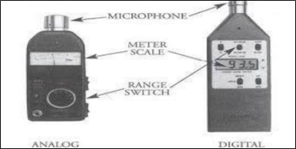

*Figure 2.1.1: Sound level meter*

**2.**    **Nirob a next generation green earth technology [2]**

It is a similar device as a library noise detector but is used in public and social areas like parks, traffic signals etc. It is a device which detects overall sound level and displays it on the Digital Board using sound sensors. Thus creating an awareness among the public. Fig 2.2.1

Apart from the noise monitor board authors of this paper also proposed a system to disable the horn of a vehicle once the vehicle enters the silent zone. This prototype made by the authors cost about 1500 INR. Authors have also developed a simple android application for vehicle users to look at their status of fine.

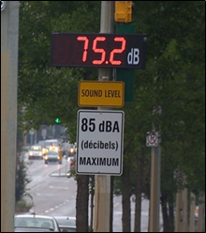

*Figure 2.2.1: Traffic noise digital display board*

**3.**    **Assessment of honking impact on traffic noise in urban traffic environment of Nagpur, India [3]**

**Study Area**

The noise assessment is done in Nagpur which comprises three roads Wardha road, South Ambazari road and Neeri road. The above assessment was done by the authors in the year 2010. These roads were aliased as national highway, major and minor roads. Fig 2.3

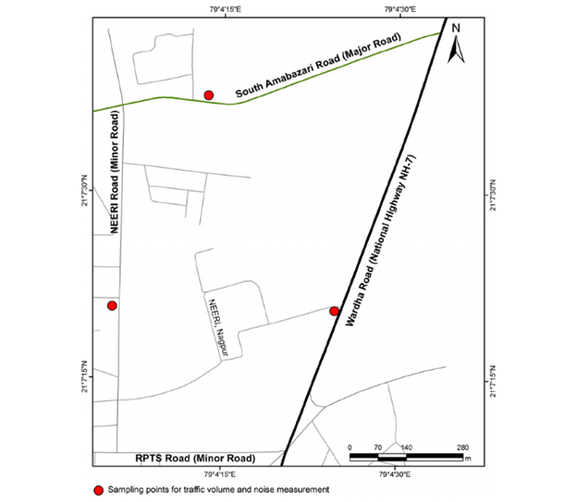

*Figure 2.3.1: Study area of assessment [3]*

The map shows the three roads where data was collected for day and night. These roads contain a major volume of traffic throughout Nagpur.

**Data Collection**

The vehicles were categorised into three type’s namely heavy, medium and light vehicles.

Heavy vehicles are trucks, bull-dozers, dumpers, etc. Medium vehicles are cars, jeeps, auto-rickshaws, loading rickshaws. Light vehicles are motorcycles and scooters.

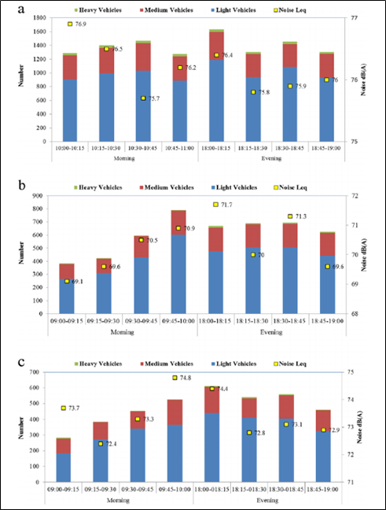

*Figure 2.3.2: data set of data for traffic and noise during morning and evening [3]*

**Data Analysis**

The roads were monitored for 24 hours so that the peak noise level can be recognized during morning and evening for each of the three roads. Based on the study, the following table was obtained in [3].

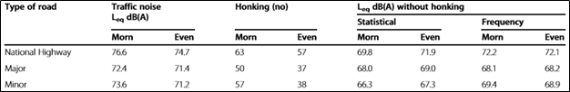

*Figure 2.3.3: Analysis of data* [3]

 From figure 2.3.2. We conclude that most of the noise was observed by light two wheeler, three wheeler. This makes them an appropriate candidate for Zona Del Silencio.

|  |
| --- |
| **Chapter 3**  **PROPOSED SOLUTION** |

**3.1 Solution:**

The proposed solution for the increasing problem of silent zones, “Zona Del Silencio” is an IoT based device which interacts with a targeted vehicle which disables the horn by a centrally controlled microcontroller.

The microcontroller works in presence of an active wireless ecosystem created in the areas covered by the silent zones using Wi-Fi technology.

Our solution also consists of an emergency switch in case of an urgent traffic situation with added object detection feature to detect presence of a vehicle ahead, to distinguish notorious drivers from the legit ones.

As a User Interface a web portal is provided for the users as well as the authorities. Here the user will be able to generate an e-receipt of monthly dues (if any). The user’s vehicle will be registered by the authorized vehicle dealer at the time of sale from the same online platform.

The online web portal also includes a section for the authorities to retrieve and monitor the notorious activities and respected dues. Also the authority is able to view individual record of a particular user provided appropriate vehicle number.

The interaction between microcontroller and database to increment the count on detected notorious activity is made possible by using micro services or API with an authorized unique key. Similarly, another data retrieval API is created to retrieve database records using HTTP GET Request.

A Host service that is a command line application using the data retrieval API is created to get records between a specified date interval and the retrieved records are stored as a spreadsheet CSV.

**3.2 Advantages of the proposed system:**

1. The integrity of the silent zones will be maintained thus reducing noise pollution exponentially leading to less disturbance in the working atmosphere.
2. NodeMCU is a compact, less expensive microcontroller, preconfigured with ESP 8266 Wi-Fi module thus making it an efficient central component for development of the prototype.
3. The end customer, the vehicle owner has transparent access to his/her records and dues related to them.
4. The authorities will be able to get records with utmost ease, through the available options.
5. Duplicate users won’t be registered since the vehicle company is the only way for registration thus making all the users authorized.
6. With the use of a modular API ecosystem, future modifications in the system won’t be complex.

|  |
| --- |
| **Chapter 4**  **WORKING ENVIRONMENT** |

**4.1 Hardware Requirements**

**Node MCU Microcontroller**

The Node MCU (Node Microcontroller Unit) is an open source software and hardware development environment. It is built on a System-on-a-Chip (SoC) called the ESP8266. It contains almost all crucial elements of the modern computer like CPU, RAM, networking (Wi-Fi), and modern operating system and SDK**.**

**Wi-Fi Router**

Wi-Fi router is an electronic device that sends data received from an Internet cable to other devices. It also acts as an access point i.e wireless access point from which data is shared through the use of radio signals. The data stream sent out of your internet is converted into radio signals by the router.

**Buzzer**

A buzzer also called as beeper is an audio signalling device. This device may be mechanical, piezoelectric, or electromechanical. Typically the buzzers or beepers are used as alarm devices, timers, and confirmation of user input such as a mouse click. In this project it is used for emergency use only.

**IR Sensor**

Infrared sensor being an electronic instrument is used to sense the surrounding depending upon certain characteristics of it. This is done by either emitting or detecting infrared radiation. Infrared sensors are also useful for measuring the heat that is being emitted by an object and detecting motion.

**Battery**

A battery is a device consisting of one or more electrochemical cell with external connections provided to power electrical devices

**Miscellaneous components**

1. **Breadboard**

The main purpose behind breadboard is to make electrical connections quickly for temporary prototype between components. Hence it is useful to test the circuit before soldering it together permanently.

1. **Jumper Cables**

These are the wires having connector pins at each end which are useful for connecting two points with each other without the need of soldering. They are typically used with breadboards for simplicity to build the circuits and modify the circuit according to the needs.

1. **Tactile Switches**

These switches mainly being used on PCBs to close an electrical circuit. Normally they are turned on only when pressure of a certain amount is applied. When the button is pressed, the switches turn ON and when the button is released, the switches turn OFF.

**4.2 Software Requirements:**

1. **Arduino**

The Arduino Integrated Development Environment (IDE) is a cross-platform application that is developed or written in the programming language Java. Arduino provides the user with an IDE where the code is written, then the written code is uploaded to the microcontroller which executes the code, interacting with inputs and outputs such as sensors, lights, etc.

1. **Php**

PHP is a popular general-purpose scripting language that is especially suited to the web. PHP is a server side scripting language that is embedded in HTML. It is used to manage dynamic content, databases, session tracking, even build entire e-commerce sites. In this project Php is used for backend purposes.

1. **MySQL**

MySQL Cluster enables users to meet the database challenges of next generation web, cloud, and communications is used for fetching query from database. In this project MySQL database is integrated with Php.

1. **HTML**

HTML stands for Hyper Text Markup Language. HTML in detail tells us the structure of a Web page i.e basically a layout. HTML is used for web page description. It makes the web page interactive.

1. **CSS**

CSS stands for Cascading Style Sheets. CSS helps the users to organize how HTML elements are to be displayed on screen in which color, fonts , etc . It is used for proper design of websites. It gives proper suitable designs which makes the web page more attractive.

1. **JS**

JavaScript is the Programming Language for the Web. JavaScript can be used to update and change both HTML and CSS. JavaScript is used to calculate, manipulate and validate data. JavaScript helps to interact with the user, control the browser, and dynamically create HTML content.

|  |
| --- |
| **Chapter 5**  **METHODOLOGY** |

**5.1 System Architecture:**

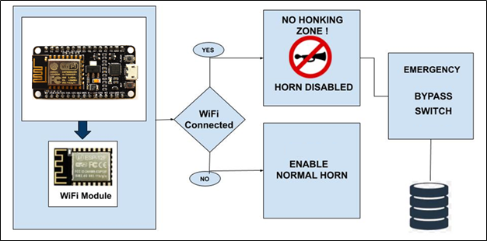

Figure 5.1.1: System Architecture

* The user vehicle will be integrated with the microcontroller, this microcontroller provides an inbuilt ESP8266 Wi-Fi module thus giving an ease of working environment.
* The node or module is programmed such that it will connect to the Wi-Fi zone established in the silent zone area.
* The device tries to connect with the router with the help of a common SSID and password predefined.
* Program for the node is written in Arduino IDE, where the device tries to connect to the Wi-Fi zone in an infinite loop.
* Wi-Fi routers installed in the silent zone act as an access point to enter in the silent zone.
* The module consists, when the vehicle enters in the silent zone a connection is established between router and device.
* A small LED is provided to let the driver know he/she has entered in a silent zone.
* This will lead to disabling of the normal horn mechanism and activate the emergency horn mechanism.
* Driver can make use of an emergency horn or emergency switch in case of an urgent traffic moment to alert the driver ahead.
* Here an IR Sensor is used to detect whether the horn was rightful or mischievous; this is done by sensing the presence of an object ahead of the vehicle.
* The database includes per vehicle count of how many times emergency has been used notoriously.
* If no object is found ahead this shall be considered as a notorious act which will cause an increment in count in the database.
* To interact with the database NodeMCU uses an API with which modification in the count is possible, for accessing the mac address of microcontroller is used.
* Analogously, when the vehicle is out of the silent zone area the device will be disconnected from the established connection thus letting the driver know that he/she is out of the silent zone through a small LED.
* The normal horn mechanism is enabled again for the use of driver
* XAMPP provides a local server with phpMyAdmin and MySQL Database which is used for development of the project.

**5.2 Workflow:**

Zona Del Silencio is an IoT based device that works solely on Node MCU which is integrated with ESP 8266 module. As the project idea describes, the horn is suppressed once the vehicle enters the silent zone. In the silent zone if a driver comes across an emergency he/she can use the emergency switch but, if used this switch mischievously a count is incremented in the database for which he/she would be penalized. The mischievous use of an emergency switch is detected with the help of obstacle detection IR sensor.

The basic workflow of the model can be understood from the below figure.

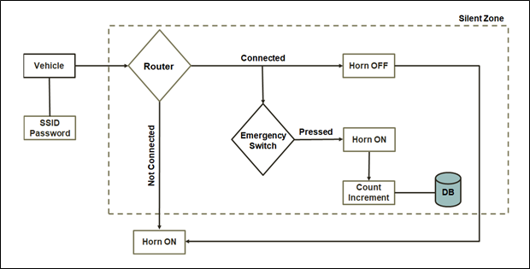

Figure 5.2.1: Workflow of Prototype

Following are the activities involved in the working of device:

1. Set up Routers: Every silent zone in the city is established with a Wi-Fi router thus indicating a wireless silent zone ecosystem. All the Wi-Fi routers are set with a common SSID and password which will help the device to connect. These routers are established such that they cover the entire area under Silent Zone guidelines.

1. Installation: From the literature survey it has been that the vehicles generating more traffic noise are two wheelers and three wheelers. Since the device is compact it can be easily installed in the vehicles.
2. The Setup:  Node MCU is programmed to establish a connection eternally with the common SSID and PASSWORD by continuously trying to connect to Wi-Fi Zone developed in Silent Zones.
3. Infinite Loop : There are two condition for NodeMCU to take an action :-

i. Connected to Wi-Fi Zone: If the vehicle is in the silent zone ecosystem, this will cause normal horn mechanism to be suppressed thus allowing an additional emergency honking switch to be enabled .This is done so that the driver won’t be able to make any noise thus maintaining integrity of silent zones. But considering urgency an emergency is provided. When the device is connected with Wi-Fi emergency switch is checked for activation, upon use of this switch a reading from IR sensor is taken to detect some obstacle in front of the vehicle. If the IR sensor provides a low output i.e. no obstacle found.an API is called with the device's mac address as a parameter to register, increment the count of the vehicle. The buzzer is turned ON to make a honk.

ii. Vehicle out of Wi-Fi Zone/ Disconnection from Wi-Fi Zone: When the device is not connected to Wi-Fi, the normal switch is checked for activation. Upon use of this switch, the buzzer is turned ON to make a honk.

1. Web Interface :

i. User Interaction - User can generate his/ her monthly dues in the form of an online fine receipt by entering the vehicle number in the website. In case of a hardcopy of the receipt, an Invoice is also generated on request by the user from the web interface as an acknowledgement.

ii. User Registration - For the user to generate his dues registration is required. A user should be registered with the device while the sale is being done by the company. Automobile Company is provided with a web interface to register the user’s vehicle number with the device's mac address. The right of user registration is only given to automobile companies so as to avoid fake users with fake number plates.

iii. Admin Panel - Admin is provided with two functionalities that is retrieve defaulters list and view per vehicle count. The defaulters list consists of users who are having their bills due. Another option is to view emergency switch count of the vehicle provided the vehicle number.

1. Standalone Application - An application is provided to authorities, a Host service that is a command line application using the data retrieval API is created to get records between a specified date interval and the retrieved records are stored as a spreadsheet CSV. This will make it for the administrator to get results easily in the same file.

|  |
| --- |
|  |

|  |
| --- |
| **Chapter 6**  **IMPLEMENTATION**  **6.1 Code Snippet**  **1.NodeMCU Program using Arduino IDE**  Figure 6.1.1 represents a program using Arduino IDE to set up the NodeMCU. The Wi-Fi module is imported at the beginning of the program for connections purpose. The initial values of various pins are mentioned. The Input/output pins are also set up as high or low as per requirement. NodeMCU will constantly try to connect with Wi-Fi in the infinite loop. With respect to Wi-Fi connection, the I/O pins are turned low or high.    Figure 6.1.1: NodeMCU program  **2.Open Report API on webserver using PHP**  Figure 6.1.2 shows the Php code to generate the report of the notorious honk count of each user vehicle. The report will be directly generated on the web server.    Figure 6.1.2: Open Report API on webserver  **3.Host Service in python**  Figure 6.1.3 shows the python code to generate the daily report of counts of the notorious honks caused by each user. Admin has to give the start date and end date and then it will generate the report in .csv format which contains the table with vehicle number and respective count.    Figure 6.1.3: Host Service  **4.API for NodeMCU to increment count**  Figure 6.1.4 shows the application written in Php format to increment the count of the notorious honks used by the user in the silent zone. Using sql update query, the count in user table is updated with increase in each notorious honk.    Figure 6.1.4: API for NodeMCU  **5.Webpage for displaying fine:**  Figure 6.1.5 shows the code written in Php format to design the webpage for displaying the fine of the user. As shown in the figure first the connection is established with the localhost. Using sql query considering the mac address of the vehicle and the count, the fine receipt is generated on the web page.    Figure 6.1.5: Code Snippet of Fine  **6.2 Screen shots & Results**  **1. Website Landing Page:**  *Figure 6.2.1: Landing Page*  Following web interface is provided for the user to check the status of dues at anytime, anywhere. Apart from this, same platform would be used to register a new vehicle with our device by connecting device’s MAC address with user’s vehicle number at automobile company.  **2. Web Receipt**  *Figure 6.2.2: Web Receipt*  The above fine is generated for the owner of ‘MH-13 20F-0729’ who has used the emergency switch 16 times mischievously. The unit for one wrong use is 100 INR.  **3. Payment receipt PDF**    *Figure 6.2.3: Payment receipt*  User is also allowed to download pdf of challan, above is the sample pdf challan. The above invoice is generated for the user from the web interface as an acknowledgement.  **4. Host Service CLI App using python**    *Figure 6.2.4: Host service*  The standalone application is provide to authorities to generate custom reports by mentioning the interval of days in form of dates. The below csv file is generated for the time period provided by the admin user in the application. Figure 6.2.4 shows the report for dates 13-01-2020 to 14-01-2020, on dummy data.  **5. Pin Diagram**  *Figure 6.2.5: Pin diagram*  Figure 6.2.5 is the pin diagram we were able to develop for the working of prototype. Instead of using the switches as a bypass circuit, the inputs of switch is read at the microcontroller and based on the status of Wi-Fi further actions are programmed. The total functionality of project is centrally controlled at the microcontroller.  **6. Schematic Diagram**  *Figure 6.2.6: Schematic Diagram*  Three digital pins are used as shown in above figure to read status of ‘Normal Switch’, ‘Emergency Switch’ and ‘IR Sensor’ and two digital pins are used to output the action on buzzer and LED – to indicate mischievous use  **Chapter 7**  **FLOW DIAGRAMS** |

**7.1 Data flow diagrams (3 lev-0, 1, 2)**

**Level 0:**

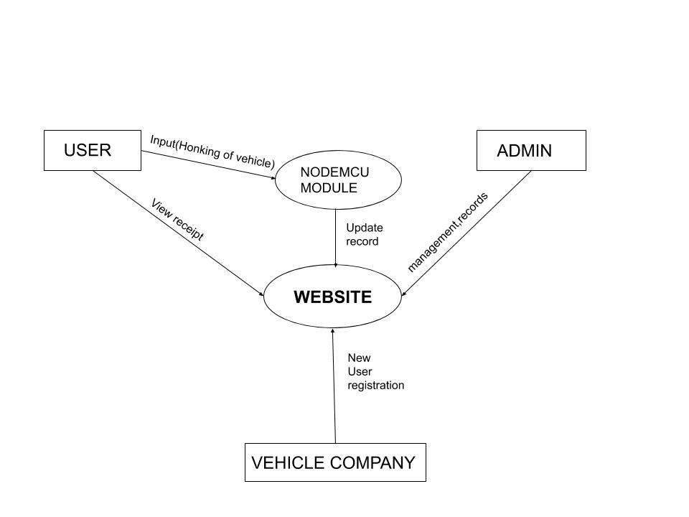

*Figure 7.1.1: DFD Level 0*

A level 0 data flow diagram (DFD) is also called as a context diagram, shows a data system as a whole and tells us how the data system interacts with external entities. Here the external entities being user, admin and vehicle company. It’s designed to be single view for the user to understand the system in a single go, showing the system as a single high-level process.

**Level 1:**

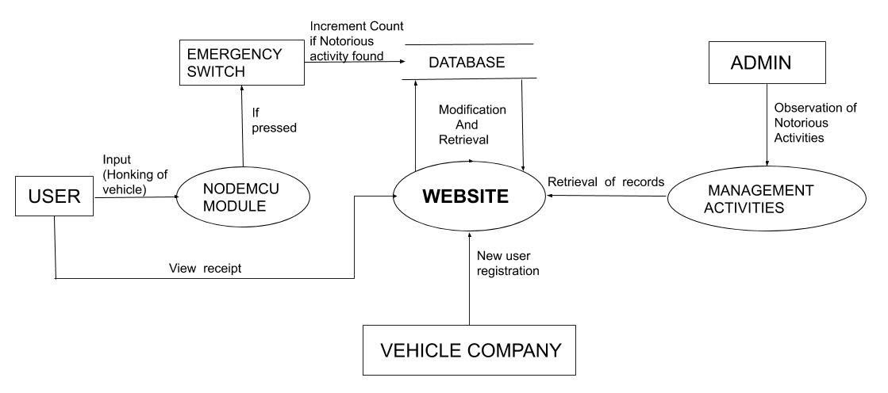

*Figure 7.1.2: DFD Level 1*

The Level 0 DFD is broken down into detail levels for easy understanding, Level 1 DFD. Level 1 DFD is used to represent basic modules in the system and flow of data among various modules. Level 1 DFD also gives the description about basic processes and sources of information. Here, the main functions carried out by the system are highlighted as we break into its sub-processes for e.g. management activities, emergency switch mechanism.

**Level 2:**

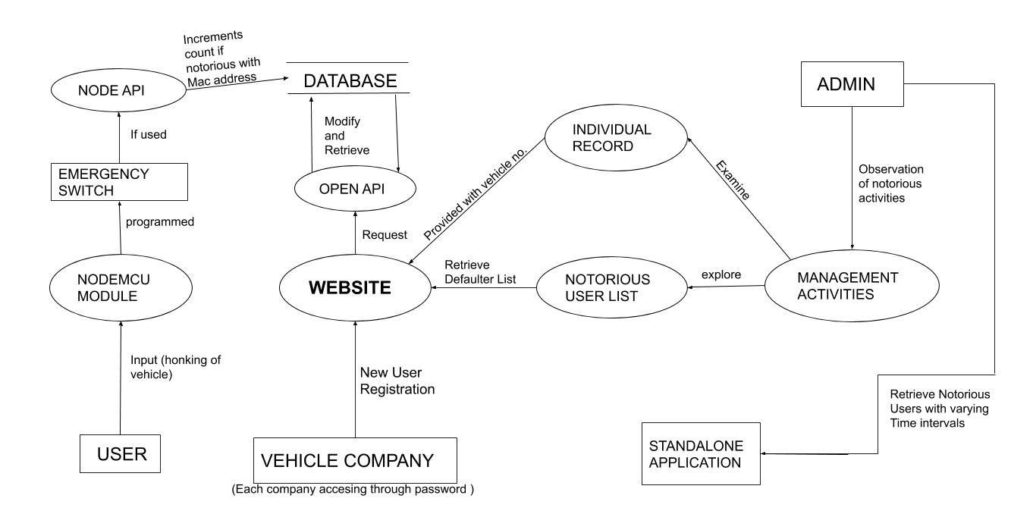

*Figure 7.1.3: DFD Level 2*

Level-2 DFD goes one step deeper into parts of level-1 DFD. It can be used to notably plan or record the specific or necessary detail about the system’s functioning. As it can be seen elaboration of level-1 process is done such as management activities includes two process namely retrieval of individual record and generate notorious users list. With the help of level-2 diagram accurate working of the system can be known.

**7.2 Sequential UML Diagrams:**

**Use Case diagram of the website:**

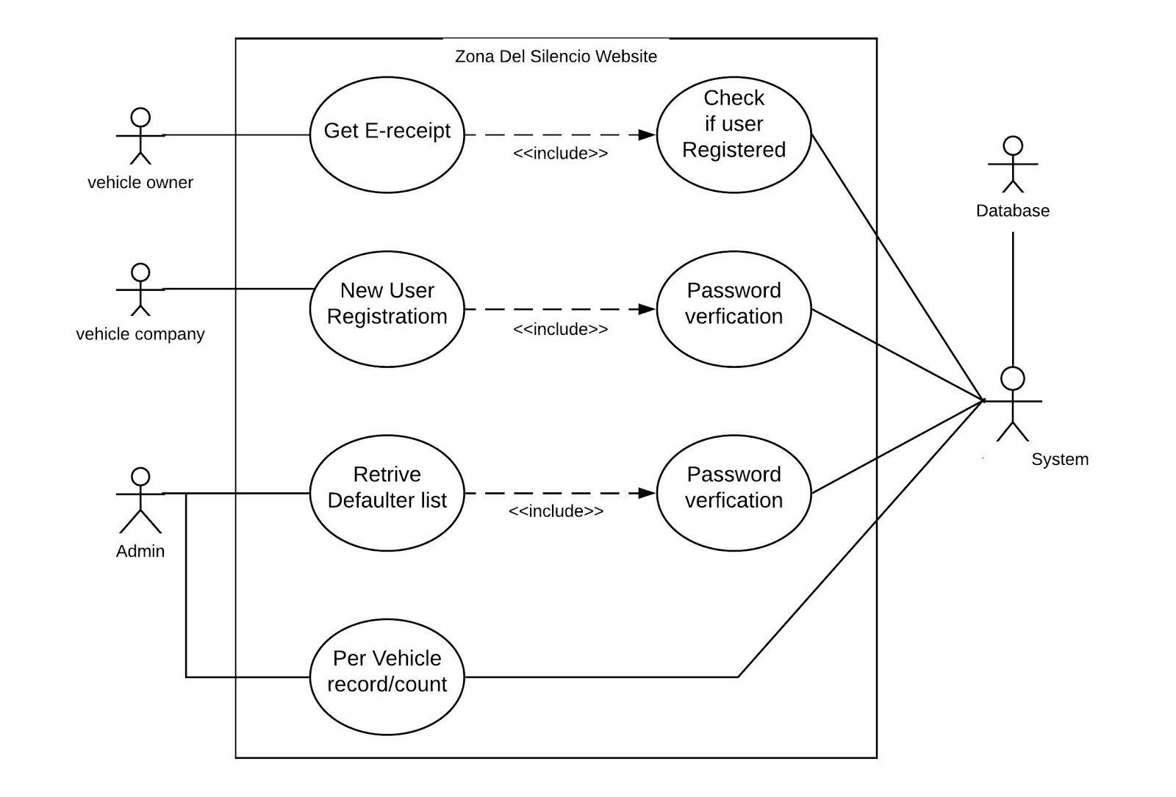

*Figure 7.2.1: UML Website*

Use cases are used to represent the functional requirements of a system. An actor is someone who interacts with use cases (system function).Actor has a responsibility toward the system (inputs), and Actor has expectations from the system (outputs). In the Fig 7.2.1, vehicle owner, vehicle company, admin etc. being the actors. A relationship is depicted with a directed arrow having a dotted line.

**Use Case diagram of the device:**

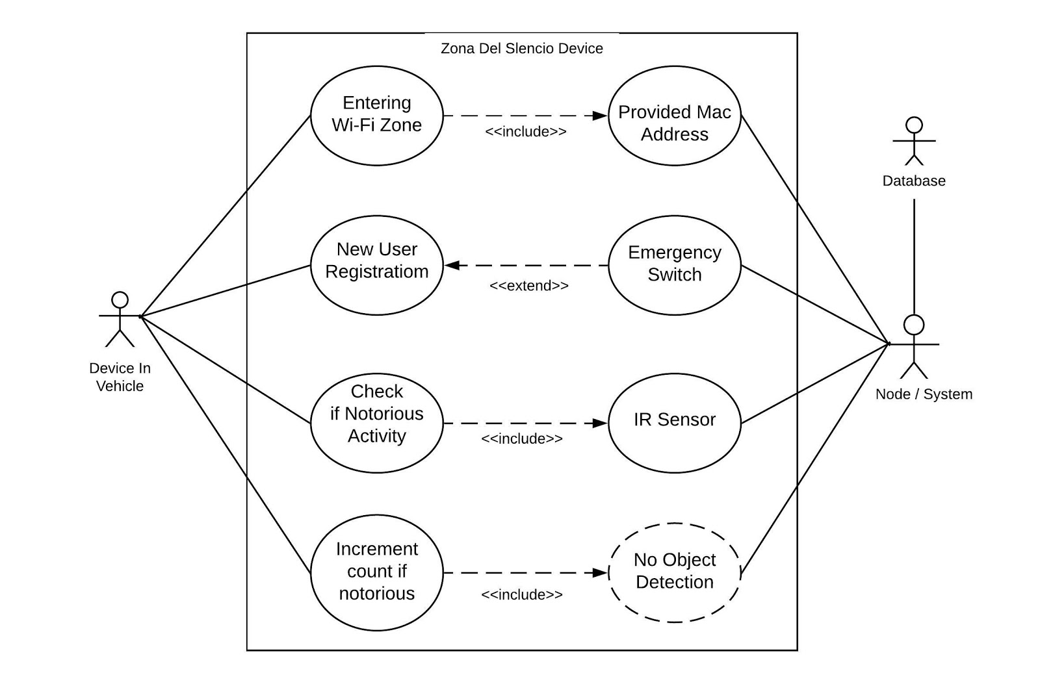

*Figure 7.2.2: UML Prototype*

Fig 7.2.2 depicts the use case diagram of the device. Here the device itself being an actor and interacting with the module functionalities. The dotted arrows having an <<include>> caption represent that the process at which it is pointing is a must.  The dotted arrows having an <<extend>> caption represent that the process at which it is pointing indicates an extra facility/function is being provided.

**8. PROJECT COST**

|  |  |  |
| --- | --- | --- |
| Sr. NO | Component | Price (INR) |
| 1 | Node MCU Microcontroller | 370 |
| 2 | IR Obstacle Detection Sensor | 50 |
| 3 | Breadboard | 60 |
| 4 | Buzzer and LED | 20 |
| 5 | Wires | 20 |
| 6 | Tactical Switch and 10 Ω resistor | 15 |
|  | **Overall Cost** | 535 |

*Table 9.1: Project cost.*

Table 9.1 describes the overall costing required for building the prototype of IOT device NodeMCU microcontroller is the central important part of the project. It is used to load the program and connect sensors. Buzzer is a sound sensor which is used to replicate horn of a vehicle. IR or Infrared sensor is used for object detection we assume that above prototype is only for testing and hence low distance IR sensor in used. Breadboard which is not a requirement is only used for testing to avoid fabrication. Switches are used to replicate horn switch of vehicle. Wires and resistors are miscellaneous items used during the project and are not required for original production device.

All the above equipment cost us 535 INR we assume that during production only the cost of IR sensor would increase NodeMCU, Breadboard, Tactical switches, Wires, Buzzer won’t be needed as these items are present in a vehicle. The NodeMCU microcontroller would be replaced by fabricated similar power processor such as ATMEGA 16.

Overall the cost presumed for the device would be lower than that of prototype.

**9. FUTURE WORK**

* In the current implementation of the prototype, IR sensor has been installed in only one direction. But it may be the case that vehicle is not in front it can be on either side of the driver and the driver by honking is indicating a turn , So in such scenario to detect the rightful activity IR sensor should be Installed in all surrounding directions.
* To make better use of the prototype or device it is needed to integrate the device with RTO so that the guidelines of silent zones will be implemented through our device. Through the prototype, the guidelines will be made more public and applicable and being a citizen of secular country everyone will follow it. Thus maintaining peace in silence zones.
* Final is we can populate a real time dataset from the readings and instances. This dataset can be used for better predictions of notorious drivers in future.

**9. CONCLUSION**

“Zona Del Silencio” is an IoT based device which suppresses the unwanted honking of vehicles in the Silent Zones. The vehicle being installed with the device detects the silence zones by sensing the Wi-Fi routers present in the zones. The driver is given an emergency switch to use in such scenarios, each time this switch is used, it is recorded in the database to check any mischievous behaviour. This way it can be easily made sure that notorious use of emergency switch is penalized.

Thus, achieving **The True Silent Zone!**

**10. REFERENCES**

[1] David, Nathan & V, Anyika & IfeyinwaN, Ejindu & AyodejiO, Abioye. (2013). LIBRARY SOUND LEVEL METER. Quest Journal of Electronics and Communication Engineering Research(JECER). 1. 20-29.

[2] Sojol, Jafrul & Shihab, Hashmi & Ahamed, Tanvir & Abu, Sayed & Siam, & Siddique, Shahnewaz. (2019). Nirob: A Next Generation Green Earth Technology Based Innovative System for Metropolitan Sound Pollution Management. 10.23919/ICACT.2019.8701955.

[3] Vijay, Ritesh & Sharma, Asheesh & Chakrabarti, Tapan & Gupta, Rajesh. (2015). Assessment of honking impact on traffic noise in urban traffic environment of Nagpur, India. Journal of Environmental Health Science and Engineering. 13. 10.1186/s40201-015-0164-4.